* So far, Single servlet involved to process the request and to generate the response.
* If more than one servlet to be involved for processing request and for generating response then we need to use **servlet Communication**. In servlet communicatin , one servlet communicates the other web components(html,jsp,servlet) to process the request and to generate the response.

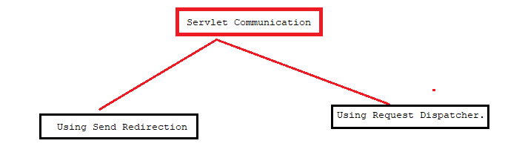

1. **Send Redirection Based Servlet Communication:**

=================================

The source servlet component talks with dest comp through browser so the dest comp can be there either in same web application or in two different web applications of same server or different servers.

The dest comp must be servlet,Jsp component ,html file, php component, asp.net component or …etc).

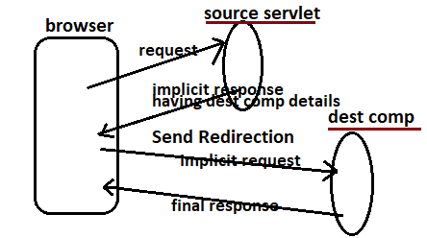

1. **Request Dispatching based Servlet Communication:**

**=======================================**

The source servlet comp directly talks with dest comp. So the dest comp must be either in same web application or in two different web applications of same server or different server.

